Bubble Gum Lab
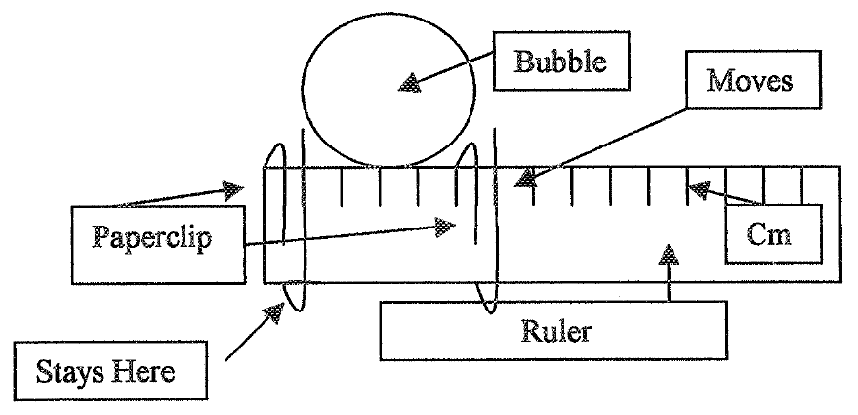
Materials: 3 brands of bubble gum, ruler, paper clips, balances, calculators

Part I: Who blows the biggest bubble?
- Make the bubble measurer.
- Blow. Measure. Record.

Name | Bubble Size (centimeter)
 | 1 | 2 | 3 | 4 | 5 | Average

Purpose: The purpose of this lab is to determine which of 3 bubble gum brands produces the largest bubbles.

Brands to compare: _________________________________________________________________________

Prediction/Hypothesis: Determine which of the brands you think will produce the largest bubbles and explain WHY you think it will.

Variables:
Independent Variable (what are you changing?): ____________________________________________

Dependent Variable (what are you measuring?): ____________________________________________

Controls (what do you need to keep the same?): ____________________________________________
____________________________________________________________________________________
____________________________________________________________________________________
Part II Best Bubble Blower blows each brand!:
- The best bubble blower will blow 5 bubbles with each brand of gum. Record the data in the table chart on the next page.
- Report your data where the leader indicates the group data is being collected.

Table Data:
Trial | Brands of Bubble Gum
 | Bazooka | Dubble Bubble | Super Bubble
1
2
3
4
5
Ave.

Group Data:
Tables | Brands of Bubble Gum
 | Bazooka | Dubble Bubble | Super Bubble
1
2
3
4
5
6
7
8
Ave.

Part III: Graphing Data
- Organize your data using Excel or Google into the following types of graphs
  - Graph 1: A bar graph that shows the average size of bubbles from your data.
  - Graph 2: A bar graph that shows the average size of bubbles from the class data.
  - Graph 3: A line graph that shows the diameter of the 10 different bubbles for each brand of gum.
- What can you learn from the graphs?

Discussion Questions:
- Why was it important to test each brand of bubble gum at least 5 times?

- How did your data compare to the rest of the group?

- What were the controls in the experiment? Why did these factors need to be controlled? Were there any other variables that could have been controlled?

