Bubble Gum Lab
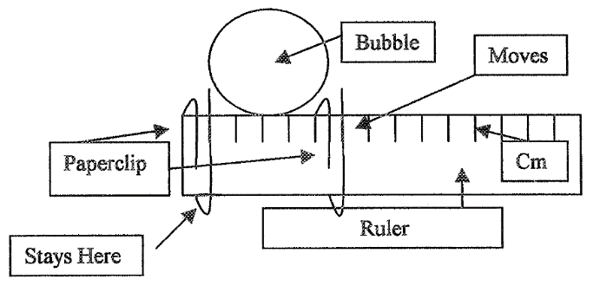
Materials: bubble gum, ruler, paper clips, calculators

Which bubble gum makes the biggest bubble?
- Make the bubble measurer.
- Blow. Measure. Record.

Name | Bubble Size (centimeter)
 | 1 | 2 | 3 | 4 | 5 | Average

Bubble Gum Lab
Materials: bubble gum, ruler, paper clips, calculators

Which bubble gum makes the biggest bubble?
- Make the bubble measurer.
- Blow. Measure. Record.

Name | Bubble Size (centimeter)
 | 1 | 2 | 3 | 4 | 5 | Average

Bubble Gum Lab
Materials: bubble gum, ruler, paper clips, calculators

Which bubble gum makes the biggest bubble?
- Make the bubble measurer.
- Blow. Measure. Record.

Name | Bubble Size (centimeter)
 | 1 | 2 | 3 | 4 | 5 | Average

